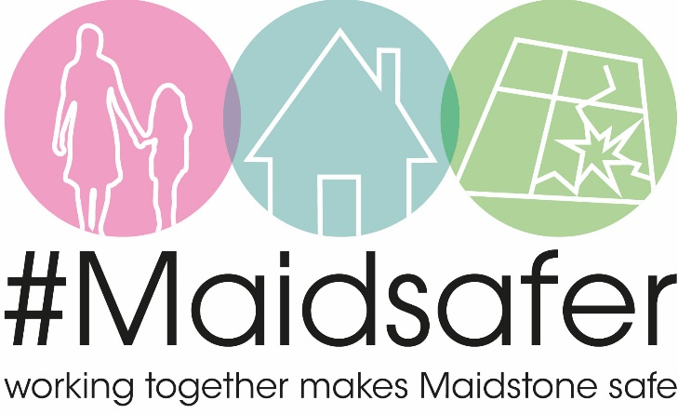
Working Together to tackle anti-social behaviour
Your role matters. Every report of antisocial behaviour helps us build a clearer picture and take effective action. Whether it’s nuisance bikes, catapults, or other concerns, small details can make a big difference.
What tools do we use?
We use a range of powers to respond proportionately and effectively:
- Warnings and Notices- Set clear expectations and consequences for behaviour.
- Conditions and Restrictions- For example, limiting where certain activities can take place or involving parents when needed.
- Interventions and diversions- For example, targeted work to encourage young people to understand the consequences of their actions, whilst undertaking a specific activity to build understanding and positive relationships.
- Escalation Options- If problems persist, we can take further steps to protect communities by use seizure powers, fixed penalty notices and even court interventions. We can even use tenancy powers where appropriate.
This approach focuses on working with families and individuals to prevent repeat behaviour and is done collaboratively with police, local authority and local housing providers to name just a few.
How you can help:
- Report incidents promptly via https://www.kent.police.uk/ or https://crimestoppers-uk.org/.
- Share this message with friends, family, and local groups.
- Encourage others to report what they see—every piece of information counts.
Why reporting is vital:
Maidstone Borough Council, neighbourhood policing teams and other partners rely on information from residents. Even if it seems minor, reporting through official channels helps us identify patterns and act sooner.
What helps most?
- Descriptions of bikes, cars, dogs etc. – unlike clothing, these often stay the same and help us link incidents.
- Doorbell footage or CCTV – even short clips can be useful.
- Names, nicknames, or known hangout spots – helps us engage early. It is very likely those responsible are members of your community and are known to some of you.
- Times and locations – build a clearer picture of when and where issues are happening.

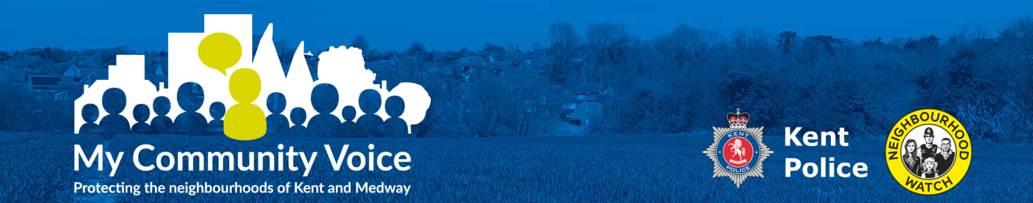
Stay Connected with Kent Police
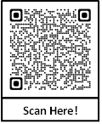
My Community Voice is a two-way engagement tool for residents, businesses and community groups in Kent and Medway.
- Participate in local surveys that directly influence your local policing priorities
- Receive news, alerts, appeals, engagement events and policing updates by email, text or voicemail.
- Share or reply to messages to help improve communication and problem-solving.
Sign up at: https://www.mycommunityvoicekent.co.uk
Together, we can keep Maidstone safe and strong.
Thank you for playing your part.

